Project: Moffat Bay | Blue Team: Jonah Aney, Justin Marucci, Nardos Gabremedhin, Amanda Wedergren
Course: CSD 460
Description: Reservation Look Up Page
Date: 02/21/2026
To complete the test case plan, fill out the information for Project, Course, Description and Date in the header below.
.
TABLE OF CONTENTS

For each test, the developer should: provide a test description, a test objective, the developer name and date tested. For each step, fill out the actions to be taken and describe the expected results, and indicate yes or no for each step depending upon the result. The peer tester should provide their name, date tested, indicate yes or no for each step depending upon the result, and a screenshot (thumbnail) of the result.

Test 1 | Look up reservation by email
 | Test Objective: Page lets you look up a reservation you made via email | Developer: Justin Marucci  Date tested:02/21/2026 | Peer tester: Jonah Aney  Date tested: 02/21/26
Step | Action | Expected results: | Developer pass/fail | Tester pass/fail  + Screenshot
1 | Log in and navigate to the reservation lookup page | Successful login, reservation lookup page loads | Yes | Yes – Screen loads correctly and displays the next steps.  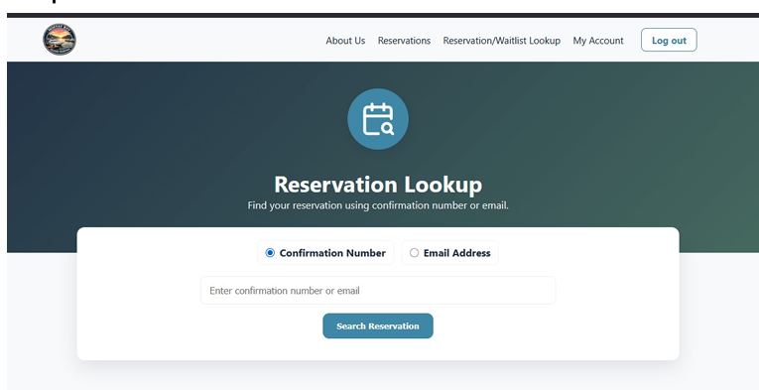
2 | Select “Email address” | Dot next to email address turns blue | Yes | Yes – button worked correctly  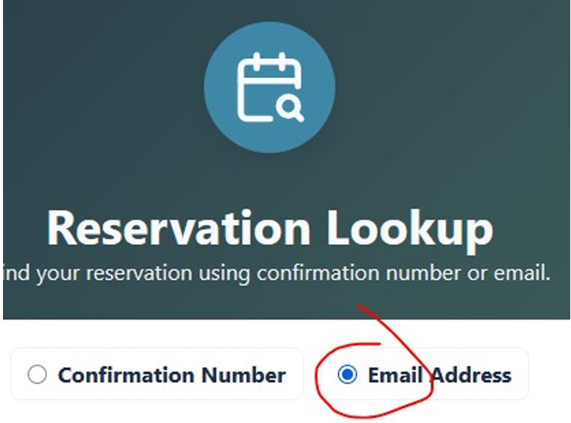
3 | Enter email address | Email appears in search box | Yes | Yes - no issues entering an email address  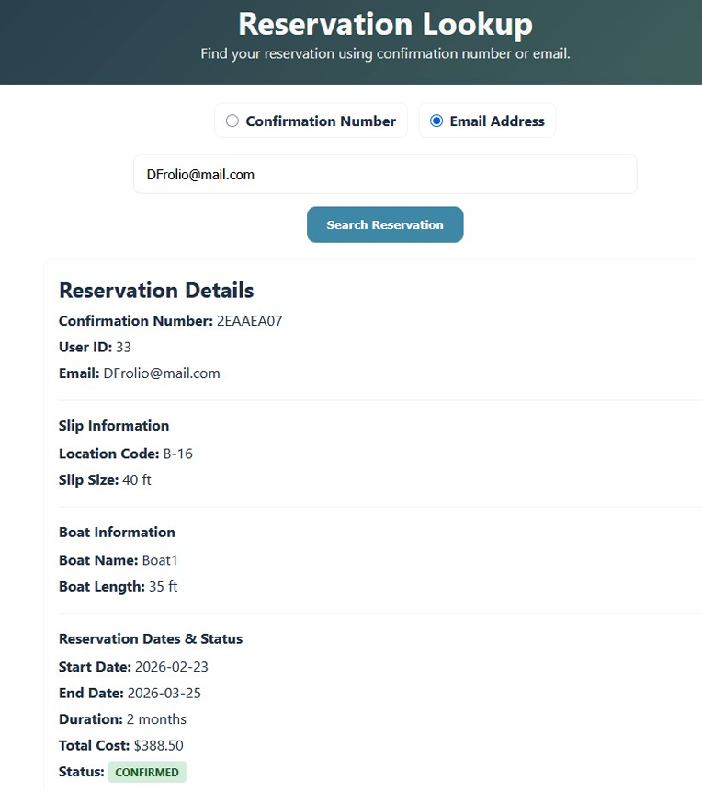
4 | Click search reservation | The reservation shows up as made by the account owner logged in | Yes | Yes – full reservation details were listed for the user.
Comments | Test works as expected. Many users may not have or know the confirmation number. Instead, they can search for an active reservation under a specific email address. This returns the expected reservation details.

Test 2 | Look up reservation by confirmation number
 | Test Objective: Page lets you look up a reservation you made via confirmation number | Developer: Justin Marucci  Date tested: 02/21/2026 | Peer tester: Jonah Aney  Date tested: 02/21/2026
Step | Action | Expected results: | Developer pass/fail | Tester pass/fail
1 | Log in and navigate to the reservation lookup page | Successful login, reservation lookup page loads | Yes | Yes – Screen loads correctly and displays the next steps.  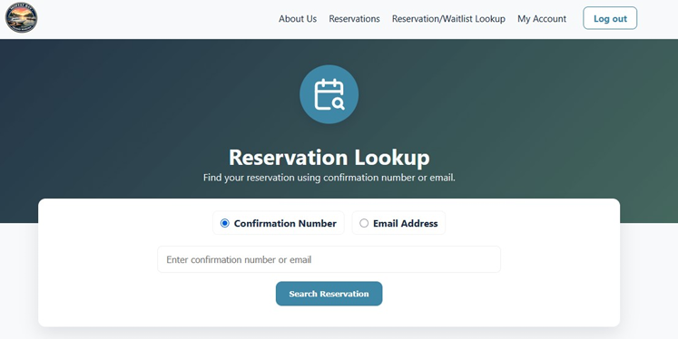
2 | Select “Confirmation Number” | Dot nect to confiration number turns blue | Yes | Yes – button worked correctly  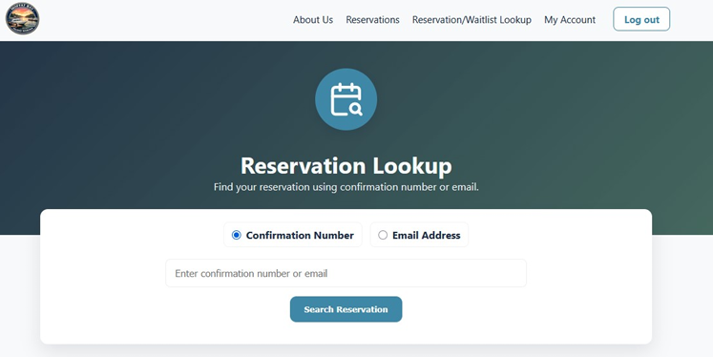
3 | Enter confirmation number | Confiration numbr appears in the search box | Yes | Yes - no issues entering a confirmation number  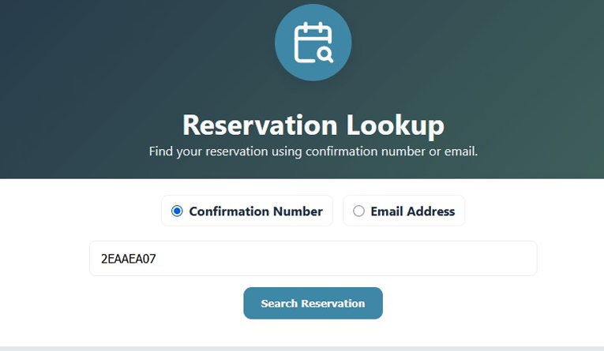
4 | Click search reservation | The reservation shows up as made by the account owner logged in | Yes | Yes – full reservation details were listed for the user.  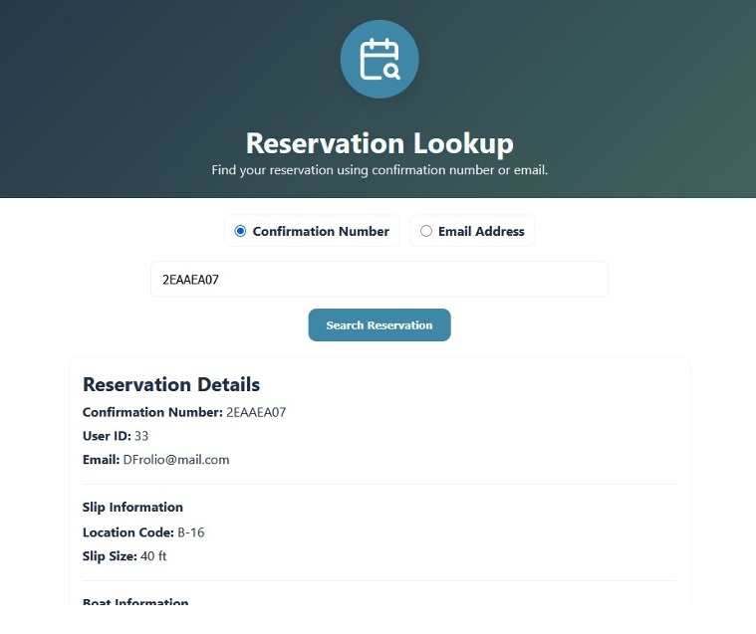
Comments | Test works as expected. A user is able to enter a confirmation number in the field. When searched, an active reservation will display information that matches the entered confirmation number.

